January 1, 2023

Training Syllabus
Table of Contents
Session Timetable 3
Level 1.1 – Own Lead 4
Level 1.2 – Own Lead 5
Level 2.1 – Yellow Lead 6
Level 2.2 – Orange Lead 7
Level 3.1 – Green Lead 8
Level 3.2 – Blue Lead 9
Level 4.1 – Purple Lead 10
Level 4.2 – Black Lead 11
Resources and Additional Information 12
Digging 14
Crate Training 16
House Training 18
Chewing 20
Jumping up 22
Biting and Rough play 24
Hierarchy of Procedures for Humane and Effective Practice 26

Session Timetable

Level 1.1 & 1.2 | Wednesday 6pm | Sunday 9am
Level 2.1 & 2.2 | Wednesday 6pm | Sunday 10am
Level 3.1 & 3.2 | Thursday 6pm | Sunday 11am
Level 4.1 & 4.2 | Thursday 7pm | Sunday 11am

Dogs can attend any scheduled session at their level
Placement is at the discretion of the Trainer based on a behaviour assessment
2023 Term Dates
2023 | Start date | Finish date
Term 1 | 30 January | 6 April
Term 2 | 24 April | 23 June
Term 3 | 10 July | 15 September
Term 4 | 2 October | 20 December

Public Holidays
Labour Day | Monday 13 March
Good Friday | Friday 7 April
Saturday before Easter Sunday | Saturday 8 April
Easter Sunday | Sunday 9 April
Easter Monday | Monday 10 April
ANZAC Day | Tuesday 25 April
King's Birthday | Monday 12 June
Friday before the AFL Grand Final | Subject to AFL schedule
Melbourne Cup | Tuesday 7 November

Level 1.1 – Own lead
Dog Trainer  Stacey McMahon  Molly Golding  Email  info@muttsabouttraining.com  Sessions (Choose 1)  6pm Wednesdays  9am Sundays | Level Overview  Covering the foundations, correct socialization & teach your dog the basics in obedience and manners  Expected Timeframe  2-4 weeks
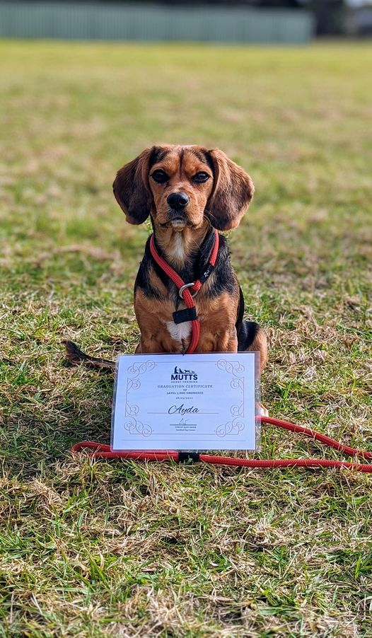
Assessment Criteria
Conditioned Reinforcers | Yes | No
Sit
Down
Recall
Touch
Bed
Heel
Loose-lead
Assessment Schedule
Assessments occur within class times by the Dog Trainer.
Homework Policy
It is recommended that the tasks are practiced at home for at least ten minutes, three times per week.

Level 1.2 – Own lead
Dog Trainer  Stacey McMahon  Molly Golding  Email  info@muttsabouttraining.com  Sessions  6pm Wednesdays  9am Sundays | Level Overview  Covering the foundations, correct socialisation & teach your dog the basics in obedience and manners  Expected Timeframe  2-4 weeks
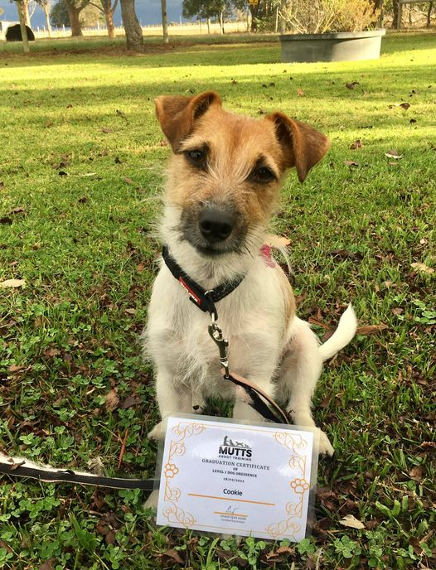
Assessment Criteria
Word Association | Position | Command | Release
Sit
Down
Recall
Touch
Bed
Heel
Loose-lead
Assessment Schedule
Assessments occur within class times by the Dog Trainer.
Homework Policy
It is recommended that the tasks are practiced at home for at least ten minutes, three times per week.

Level 2.1 – Yellow Lead
Dog Trainer  Stacey McMahon  Molly Golding  Email  info@muttsabouttraining.com  Sessions  7pm Wednesday  10am Sundays | Level Overview  Building on level 1 we train you and your dog to achieve reliable basics adding distance, and distractions so that we can start to use our obedience in real time.  Expected Timeframe  2-4 weeks
Assessment Criteria
Task | Duration | Distance | Distraction
Sit | 30 seconds | 1 step | Low
Down | 30 seconds | 1 step | Low
Bed | 30 seconds | 1 step | Low
Basic Heel | 3 metres |  | Low
Loose-lead | 10 metres |  | Low
Touch | 4 points |  | Low
Recall |  | 2 metre | Low
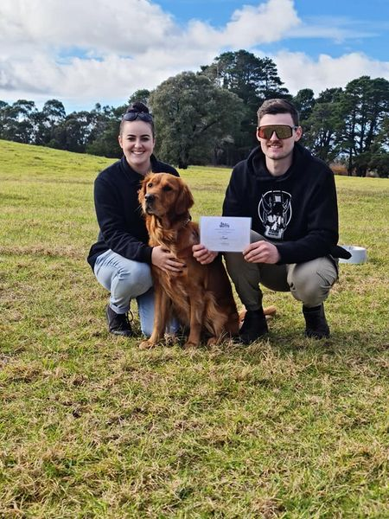
Assessment Schedule
Assessments occur within class times by the Dog Trainer.
Homework Policy
It is recommended that the tasks are practiced at home for at least ten minutes, three times per week.

Level 2.2 – Orange lead
Dog Trainer  Stacey McMahon  Molly Golding  Email  info@muttsabouttraining.com  Sessions  7 pm Wednesday  10am Sundays | Level Overview  Building on level 1 we train you and your dog to achieve reliable basics adding distance, and distractions so that we can start to use our obedience in real time.  Expected Timeframe  2-4 weeks
Assessment Criteria
Task | Duration | Distance | Distraction
Sit | 30 seconds | 1 step | Low/Medium
Down | 30 seconds | 1 step | Low/Medium
Bed | 30 seconds | 1 step | Low/Medium
Basic Heel | 3 metres |  | Low/Medium
Loose-lead | 10 metres |  | Low/Medium
Touch | 4 points |  | Low/Medium
Recall |  | 2 metre | 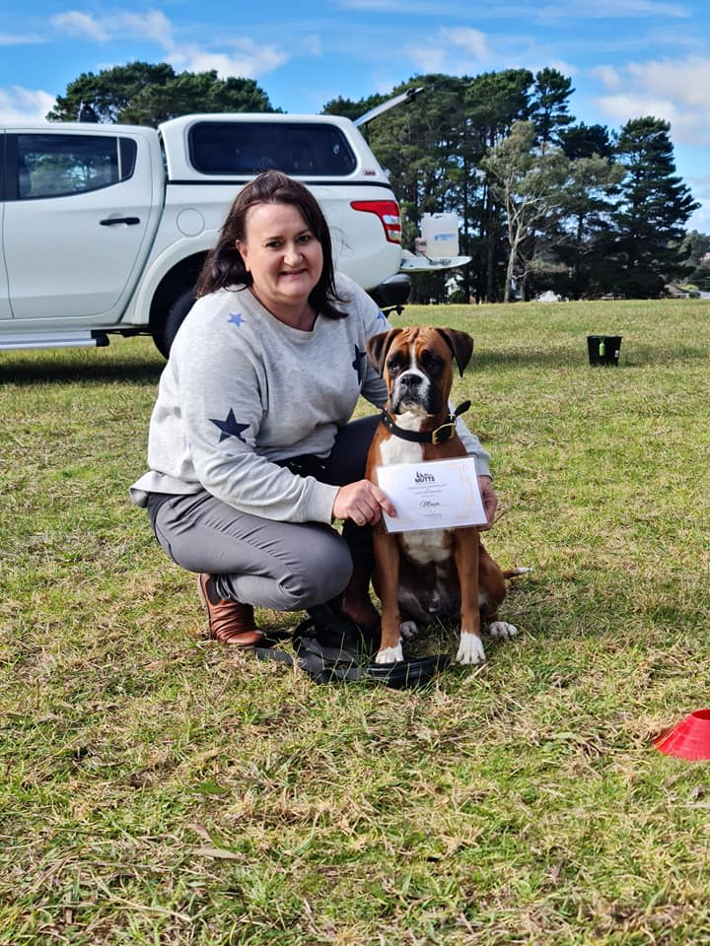  Low/Medium
Weave |  | 3 metre | Low/Medium
Assessment Schedule
Assessments occur within class times by the Dog Trainer.
Homework Policy
It is recommended that the tasks are practiced at home for at least ten minutes, three times per week.

Level 3.1 – Green lead
Dog Trainer  Stacey McMahon  Molly Golding  Email  info@muttsabouttraining.com  Sessions  6 pm Thursdays  11am Sundays | Level Overview  Building on level 1 we train you and your dog to achieve reliable basics adding distance, and distractions so that we can start to use our obedience in real time.  Expected Timeframe  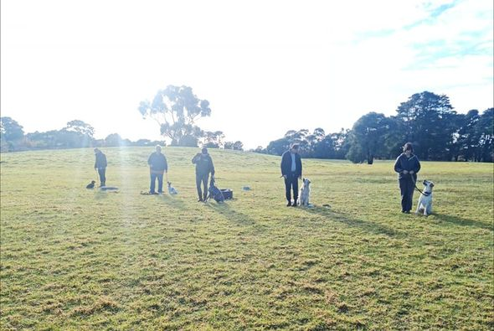  2-4 weeks
Assessment Criteria
Task | Duration | Distance | Distraction
 | Duration | Distance | Distraction
Sit | 1 minute | 2 steps | Low/Medium
Down | 1 minute | 2 steps | Low/Medium
Bed | 1 minute | 2 steps | Low/Medium
Intermediate Heel | 5 metre |  | Low/Medium
Loose-lead | 15 metres |  | Low/Medium
Touch | 2 x 4 points |  | Low/Medium
Recall |  | 10 metres | Low/Medium
Assessment Schedule
Assessments occur within class times by the Dog Trainer.
Homework Policy
It is recommended that the tasks are practiced at home for at least ten minutes, three times per week.

Level 3.2 – Blue Lead
Dog Trainer  Stacey McMahon  Molly Golding  Email  info@muttsabouttraining.com  Sessions  6 pm Thursdays  11am Sundays | Level Overview  Building on level 1 we train you and your dog to achieve reliable basics adding distance, and distractions so that we can start to use our obedience in real time.  Expected Timeframe  2-4 weeks
Assessment Criteria
Task | Duration | Distance | Distraction
Sit | 2 minutes | 3 metres | Medium
Down | 2 minutes | 3 metres | Medium
Bed | 2 minutes | 3 metres | Medium
Intermediate Heel | 10 metres |  | Medium
Loose-lead | 20 metres |  | Medium
Touch | 2 x 4 points |  | Medium
Recall |  | 10 metres | Medium
Assessment Schedule
Assessments occur within class times by the Dog Trainer.
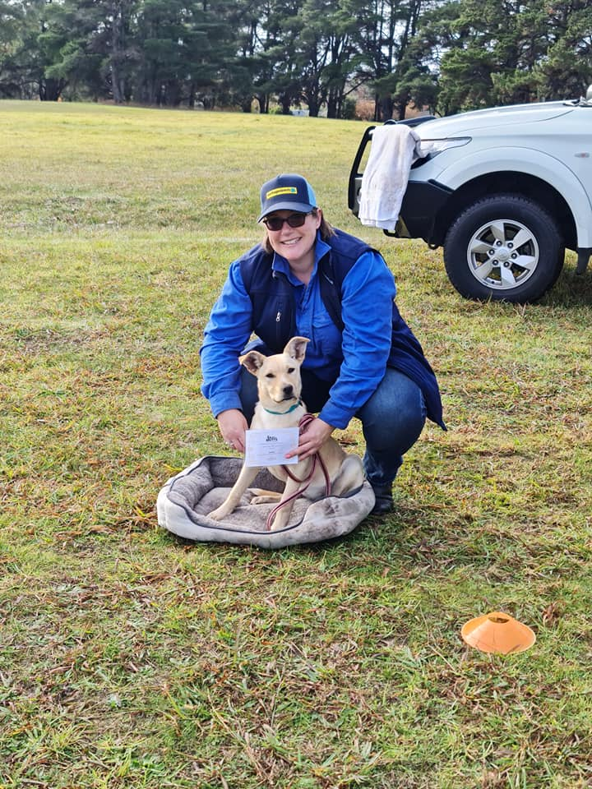
Homework Policy
It is recommended that the tasks are practiced at home for at least ten minutes, three times per week.

Level 4.1 – Purple Lead
Dog Trainer  Stacey McMahon  Molly Golding  Email  info@muttsabouttraining.com  Sessions  7pm Thursday  11pm Sundays | Level Overview  Building on level 1 we train you and your dog to achieve reliable basics adding distance, and distractions so that we can start to use our obedience in real time.  Expected Timeframe  2-4 weeks
Assessment Criteria
Task | Duration | Distance | Distraction
Sit | 3 minutes | 3 metres | Medium/High
Down | 3 minutes | 3 metres | Medium/High
Bed | 3 minutes | 3 metres | Medium/High
Advanced Heel | 20 metres |  | Medium/High
Loose-lead | 30 minutes |  | Medium/High
Touch - object | Complex skills |  | Medium/High
Recall |  | 20 metres | 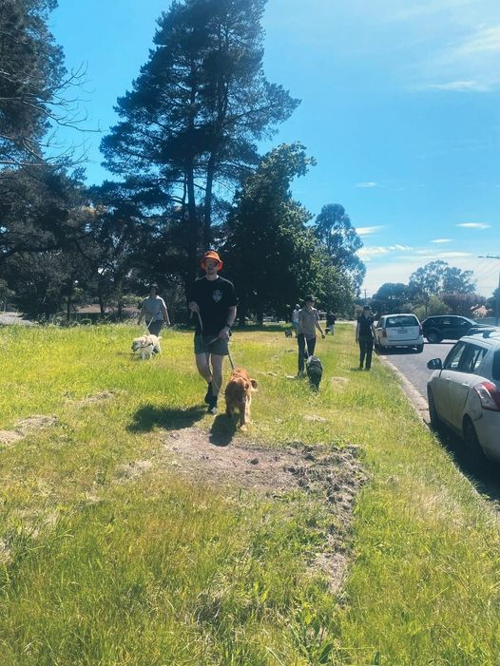  Medium/High
Assessment Schedule
Assessments occur within class times by the Dog Trainer.
Homework Policy
It is recommended that the tasks are practiced at home for at least ten minutes, three times per week.

Level 4.2 – Black lead
Dog Trainer  Stacey McMahon  Molly Golding  Email  info@muttsabouttraining.com  Sessions  7pm Thursday  11pm Sundays | Level Overview  Building on level 1 we train you and your dog to achieve reliable basics adding distance, and distractions so that we can start to use our obedience in real time.  Expected Timeframe  2-4 weeks
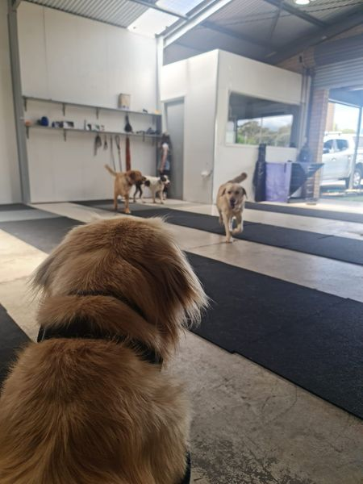
Assessment Criteria
Task | Duration | Distance | Distraction
Sit | 3 minutes |  | High
Down | 3 minutes |  | High
Bed | 3 minutes |  | High
Advanced Heel | 20 metres |  | High
Loose-lead | 30 minutes |  | High
Touch - object | Complex skills |  | High
Recall |  | 20 metres | High
Assessment Schedule
Assessments occur within class times by the Dog Trainer.
Homework Policy
It is recommended that the tasks are practiced at home for at least ten minutes, three times per week.

Ninja dog academy
To be eligible to join the scheduled ninja class on Sundays you must first pass Obedience level 1.1 and 1.2 (this is the absolute basics in obedience and focus to set you up to succeed)
Ninja Dogs
We have mixed a bunch of mad skills into one to create ninja dogs. We have done our best to provide a FUN and BENIFICIAL program for dogs and owners.
In the ninja dog program we train Agility with some parkour and balancing equipment included to really test your dog and create some confidence and trust. We also have the ability to help you learn some fun tricks with our complex skills such as Quoits, skateboarding, Directional retrieve, touch and so much more! There is so much to learn and do with your dog and we want to help you achieve this.
Obedience Classes are scheduled every week, sometimes twice a week for you to join us when it suits you to pass level 1.1 and 2.1 so that you may join our Ninja Dogs.
Check out out schedule to make sure you come to the correct days and times for the level you are currently in or graduated to.
Level -Time -Day
L1.1 & 1.2 - 6pm -Wednesday
L2.1 & 2.2 - 7pm -Wednesday
L3.1 & 3.2 - 6pm -Thursdays
L4.1 & 4.2 - 7pm -Thursdays
Sundays..
L-1.1 & 1.2 - 9:00 am
L-2.1 & 2.2 -10:00 am
L-3.1 -11:00 am
L-3.2 -11:00 am
L-4.1 & 4.2-11:00 am
If you are late don't worry ! we have 2 trainers on Sundays so that we can cater to everyone's needs and you can still get your training in :)

Ninja Dogs Class - 12:00-2:00 Sundays only!

Resources and Additional Information

READING MATERIAL:
I advise having a read of the article produced by the Times about dog training and the science behind different methods and how we now approach dog training.
Below you will see the Hierarchy Table created by Susan G. Friedman, Ph. D. Department of Psychology. Utah State University, Logan, UT
https://time.com/5880219/science-of-dog-training/
Here is an image of a road map explaining the process of modifying behaviours. Also found in this article.
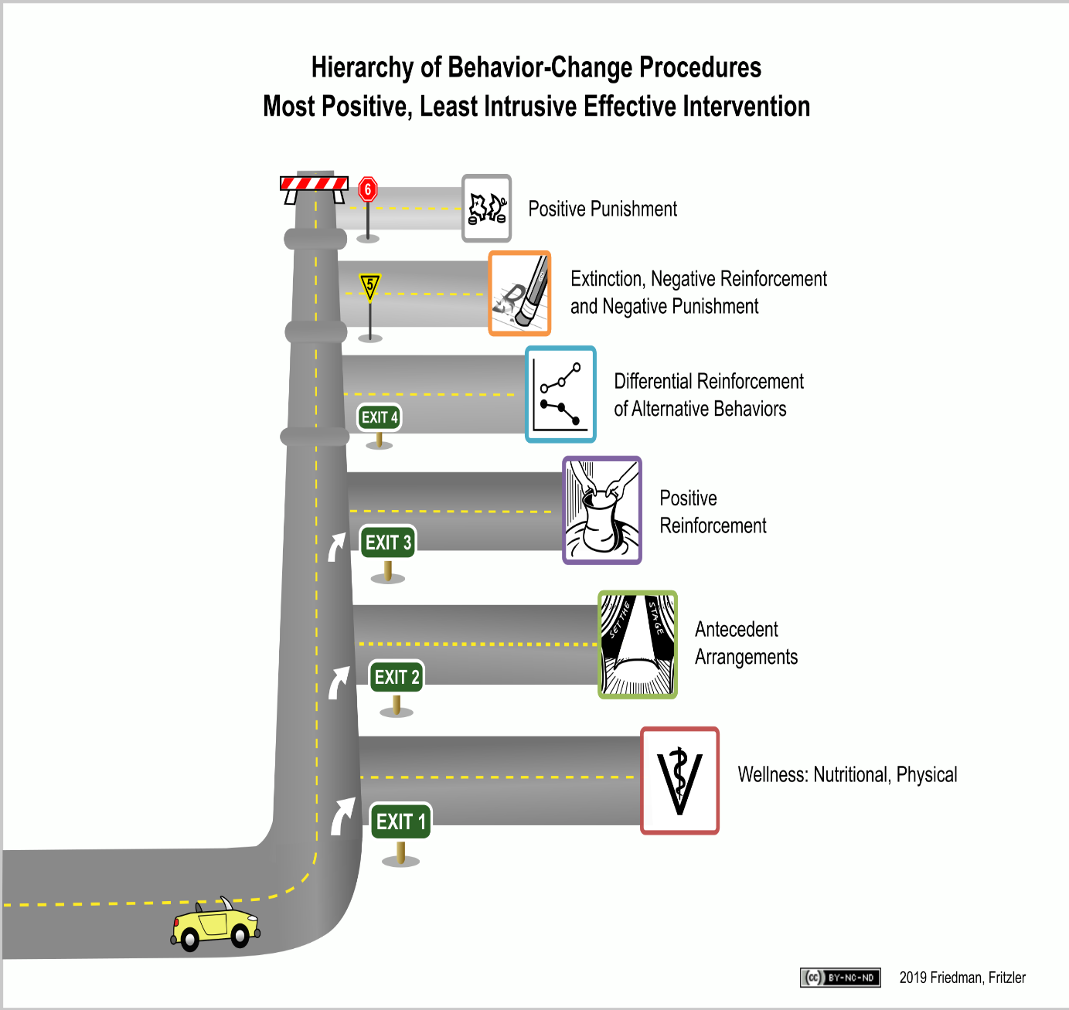

Digging
Inappropriate or destructive digging is a common problem. Determining what is motivating your dog to dig will help to create a behaviour modification plan to redirect and control this behaviour.

Why Is My Dog Doing That?
Most dogs dig out of boredom or social isolation. If your dog is left outside by himself for long periods of time (or even short periods) he will likely resort to entertaining himself. Digging is just plain fun for your dog! Supervising your pet while outside is critical in encouraging appropriate behaviour. Other reasons that may motivate your dog to dig:
• Seeking comfort from hot or cold weather.
• Trying to escape from an enclosure, like a fenced in yard.
• Predation or hunting behaviours, common in terrier breeds.
• Attention seeking behaviour.
• Relieving excess energy.
It is important to identify which of these issues may be causing you dog’s inappropriate behaviour. Each situation is different and will require unique approaches and management techniques.
Managing Your Environment
It is best if your dog lives inside with you but if your pet must spend time outside unsupervised you will need to manage your environment to create good habits. Providing an acceptable digging area for your dog can save you a lot of headaches and destroyed flower beds. Pick a place in your yard that you are going to allow your dog to dig and create a digging playground. A digging playground should have soft soil and you should keep it clean from debris. You can bury safe and enticing items for your pet and encourage him to find them. This will positively reinforce him to dig in his special area. If you catch your dog digging in unacceptable areas interrupt the behaviour with a loud clap of your hands and redirect him to his playground. Offer lots of verbal praise if you catch your dog digging in the area you have provided.
If your dog is digging around or under the fence and excavating escape routes you will need to ensure his safety by creating a secure fence line. Modifying your fence may take some work on your part. Some suggestions: You can bury chain link fencing below your current fence to add an extra two feet of depth protection. Try laying chain link (you may also use chicken wire) out flat from the bottom of your fence a few feet. If you put this a couple inches under the ground when your dog digs he will reach the chain link quickly.
Your dog will not enjoy this experience and if the behaviour ceases to be rewarding your dog will unlikely continue the behaviour. You can try creating a barrier around the bottom of your fence with large stones or cinder blocks. Smaller stones or gravel (one to two feet wide and a few inches deep) around a fence line will also make an unattractive digging area.
If your dog is expressing predatory behaviours (hunting) by digging, you may have burrowing animals (such as insects) in your yard. In order to control the digging you have to get rid of the cause. Calling in a professional may be necessary to rid your yard of any unwelcome visitors. Use caution and only use methods of removal that will not be toxic or harmful to your pet.
Encouraging Appropriate Behaviour
There are lots of things you can do to help your pet make good choices. It is up to you to train your dog or puppy and start him off on the right paw! Limiting his ability to make mistakes will prevent bad habits from forming. Set him up for success.
• Always supervise your pet when he is outside.
• Sign up for a basic dog obedience class (you can call 954-266-6855 to register for a low cost class at the Humane Society of Broward County).
• Be aware of breed characteristics. Terrier breeds were bred to dig, so have realistic expectations.
• Provide plenty of one- on- one time with your pet.
• Ensure your dog or puppy is getting enough exercise and play time (see the Exercise handout for more info.).
• Provide plenty of interesting toys and activities to keep your dog busy when he is alone.
• If your dog must spend unsupervised time outside make sure he has adequate shade from the hot sun (a baby pool filled with water can help your pet stay cool too) and a comfortable shelter that will provide protection from cold weather, wind and or rain.

Avoiding the Pitfalls Using punishment after the fact will not correct the undesired behaviour and may result in other behaviour problems emerging. Even if caught in the act physical punishment will not address the cause of the behaviour and could even make things worse.
• Your dog or puppy may learn to be afraid of you.
• He may become defensive and develop aggressive behaviours.
• He could shy away from physical interactions with you, like not wanting to be petted.
• Fearful behaviours will influence future training and make learning difficult for your pet.

Crate Training
If introduced properly the crate can be the answer to many behaviour problems that are driving you crazy. A dog can’t destroy your house or eliminate on your carpet if he is being crated. Plus dogs are naturally den animals. They enjoy a safe retreat away from the hustle and bustle, and it gives them a place to call their own.
Choosing a Crate
When selecting a crate for your pet you should consider size and function. The size of the crate should be big enough for your dog to stand up, turn around and lay down comfortably. If the crate is too big your pet may be able to eliminate at one end and easily sleep at the other end. This would create a bad habit of crate soiling and weaken your dog’s natural genetic predisposition of keeping his living area clean. The function of the crate is simply to provide confinement for your pet when he cannot be supervised. Crates come in basically two types, wire or plastic. Wire crates are easily moved around the house and provide the ability for the dog to be able to see what is going on around him. Plastic crates (airline type carriers) have solid sides and tend to be a little sturdier. Keep in mind if you are selecting a crate for your puppy that he is growing and may have to grow into his crate. You can use a larger crate and block space by using a divider or a milk crate inside.
Selecting the Perfect Place
Now that you have the crate where do you put it? If crating your pet at night you will probably want to put the crate in your bedroom. Being close to you will help to relieve stress and make your pet feel more comfortable in his crate. You will also be able to hear if your puppy becomes restless. Very young puppies will have limited ability to hold their bladder or bowels and may need to go out in the middle of the night. If you are also crating your pet while you are at work or just out of the house the crate should be in a cool, dim lighted and quiet area (this helps to stimulate sleep cycles). You may even want to crate your pet occasionally when you are home, like when you are cooking dinner. In this case you should have the crate in the family area where your pet can see you so he is not isolated. Having more than one crate may be more convenient if you do not want to have to move the crate around.
Starting the Process of Training
First impressions are important. When you begin all experiences between your dog and his crate must be positive and rewarding for him. Allow him to approach the crate to investigate, verbally praise your dog if he shows any interest in the crate and toss a few treats inside to entice him to enter on his own. The treats should be a high value item like freeze dried liver, a small bit of hot dog or cheese, something he is really going to like. Do not close the door at this point. Allow the dog to become accustom to the crate. Play with him with his favorited toy in or near the crate. Feed him his meals in or near the crate. Give him a special treat by placing it in the crate, like a stuffed KONG toy (or any hard chew toy you can stuff with something yummy). The important thing to remember is baby steps. Once your dog feels comfortable around the crate you can start to close the door and leave him in it for short periods of time. Use the special stuffed chew toy to encourage him to enter, leave the toy for him to enjoy and close the door. Only leave him in the crate for a few minutes and then let him out. Gradually increase the amount of time he is in the crate over a period of a few days. Never let him out of the crate when he is crying always wait for that small moment of silence or you will be rewarding the crying and he will soon learn that this behaviour will work to be released. Always use the crate in a positive manner and never for punishment and do not abuse the crate by keeping your pet in it for long periods of time.
Now that you have a plan for introducing and using a crate here are some helpful tips and hints that will make crate training even easier.
• Some dogs and puppies will experience stress related to crate training and it is important to take it slow and not rush your pet.
• Never physically force your pet into the crate. This will cause a negative impression and possibly make your dog afraid of the crate. You could also cause injury to yourself or your pet.
• Try leaving a TV or radio on to make him feel less alone. This will also help to block out background noise that may stimulate your dog to bark or feel nervous. Play something soothing and not to loud. • Covering a wire crate with a blanket will help create a cozier place when your pet is sleeping. This will also block his view from anything that may stimulate him to bark or feel nervous.
• Crate training may take days or even weeks remember to be patient.
• While training use a verbal cue or command such as “kennel up”. You will be able to use this later to ask your dog to go into his crate.
• Practice unemotional hellos and goodbyes when leaving your dog in the crate and upon returning. You want to keep it low key and not reward overly excited greetings or departures.
• If crating a puppy (overnight) he will probably need to eliminate sometime during the night. It is important to recognize if your dog or puppy is crying when in the crate because they need to go outside to eliminate. This may take a little time but you should be able to tell the different types of crying. “I want out of my crate” crying may be louder and more demanding. “I have to go to the bathroom” may be a whine or softer crying. You may also notice your dog becoming more restless and anxious if he has to go out.
• Caution should be used if you think your dog is suffering from separation anxiety. Using a crate could cause injury to your pet and may intensify his phobic behaviour. You should consult your veterinarian if you think your dog has separation anxiety.

House Training
House training your pet may be one of the most important things that he learns. Starting off on the right foot is very important, decide what your goals are going to be with house training from the very first day and work towards that goal together. If given a choice your puppy may make mistakes and have accidents and this is a pitfall we want to avoid. If allowed to make mistakes routinely your pet will soon develop a habit and training will be frustrating and confusing for him. The goal is usually simple…you want your pet to readily and consistently eliminate outside and we can get that done in eight easy steps!
1. SUPERVISION - Supervising your pet is critical to the success of house training. When your pet cannot be 100% supervised then he should be in a long term confinement area (like a kitchen with a baby gate) or his crate. Another good way to keep your pet close to you is to use a leash that can be hooked to your belt loop or around your waist, this method may not work for everyone but can be considered an option. Keeping an eye on things helps to eliminate accidents and will make house training quick and easy. The week of age of your puppy is the amount of minutes a puppy can hold there bladder so if you have a 8week old puppy he can only hold on for 8 minutes so taking your dog to potty regularly is very important.
2. ELIMINATE ACCIDENTS – You can easily eliminate accidents by supervising your pet and supervision while in the home will also help to curtail other behaviour problems like chewing inappropriate items. Eliminating accidents is important to keep your pet from developing bad habits. If allowed to routinely make mistakes house training will take longer and be more frustrating for you and your pet.
3. DEVELOP A ROUTINE – Dogs thrive on and come to expect routine in their lives. Developing a routine when it comes to feeding and eliminating will set a schedule and start a good habit. Meals should not be free fed but should be fed around the same time each day (three times a day for puppies and twice a day for adults). Vary feeding times to reduce stress and expectation behaviours in your pet. Feeding in the morning and then again in the evening for adult dogs (but not at exactly the same time every day) will create better behaviours in your pet’s routine. Once the food is put down allow 10 to 15 minutes for him to eat and then whatever is left pick up. It will be much easier to predict what time it has to come out if you know exactly what time it when in. The routine should also include going outside to eliminate and the general expectation for when a dog will have to go is: 30 minutes or so after eating or drinking, when he wakes up (even from a nap) and after play, activity or exercise.
4. ELIMINATE ON COMMAND – Sounds impossible but it is a very important part of the plan. When your pet is outside he should always be accompanied by you and be on lead. A cue or command should be used…..hurry, hurry, go potty, or whatever you choose as long as it is the same cue each time. Select an area of the yard to be the bathroom and stay in that spot. Walking around and smelling the flowers can be a source of distraction to your pet.
5. REWARD – Now comes the reward. When your puppy goes (and he will) verbally praise him and offer a food treat. The food reward should be a high value item like a small piece of cheese, hot dog or freeze dried liver. The treat needs to be delivered quickly after elimination (within 3 seconds) in order to positively reinforce that behaviour. Note: be careful verbal praise is not too exciting and interrupts elimination.
6. BE CONSISTENT – Continue your training daily and do not skip a day because you get busy or it is raining outside. Do not vary the routine or change the command. Changes or lapses in training will be confusing for your pet and house training will take longer. Stick to the plan. Most puppies will need at least 21 days straight without any accidents to have training solidly in place and you may want to push that to 30 days just in case you may have missed an unknown accident. Some remedial training may be necessary if the puppy is stressed or the routine changes.
7. ELIMINATE PUNISHMENT – It just does not work! Punishing your pet after the fact may even damage your emotional bond and he may become afraid of you or afraid to eliminate in front of you. If you catch your puppy in the act interrupt him with a loud HEY and clap your hands. This is not yelling at or verbally reprimanding your pet but simply interrupting the undesired behaviour. Remember to lose the upset attitude about having caught your puppy making a mistake and use an upbeat voice “you want to go outside” and immediately take the puppy outside. Praise him and offer a food reward when he eliminates outside.
8. CLEAN UP – This step is very important. Odours left on carpet or the floor are like a big red flag saying “go here, go here!” Always use an enzyme cleaner to get rid of odours and stains. Most cleaners can be found at a local pet store, your veterinarian or here at the humane society’s pet boutique.
Now that you have a plan in place
Here are some helpful tips and hints that will make training even easier.
• If you do not have a yard and walk your pet to eliminate remember to still pick a bathroom spot. Dogs like going for walks and if the walk is over as soon as they go to the bathroom then they will likely hold out as long as they can in order to extend the walk, often not eliminating completely, if at all. Use the bathroom spot first and offer a food reward and then your pet gets a double whammy reward by going for a walk.
• Some people try to cut corners by waiting at the back door with a treat for their pet and once they come inside then they get the treat. From the dog’s point of view you have just rewarded him for coming back to the door and coming in and not for eliminating outside at all. It is important to be with your pet in the yard and deliver the treat within 3 seconds of the desired behaviour.
• Giving plenty of opportunities to a new puppy to go outside is critical. You would be amazed at how many times a puppy can actually have to go! The frequency can be reduced as your puppy gets older.
• A general rule of thumb for puppies when house training or crate training is that they can only hold it about one hour for every month they are old plus one. So if you have a 3 month old puppy he will only be able to hold it for about 4 hours. As your puppy gets older his bladder and bowel control will increase.
• Keep in mind if you have a tea cup or a miniature breed pet they are very small and their organs inside are small too. The ability for them to hold it for extended periods of time is very limited and they will need to eliminate frequently simply because they are too small to hold too much.
• If problems occur and accidents are difficult to overcome it is important to ensure of clean bill of health and a trip to your veterinarian may be in order to rule out any existing medical problems.
• Patience, patience, patience.

Chewing
Destructive Behaviour
Destructive chewing is number one on the hit list when it comes to problems with destructive behaviours. There are others, but inappropriate chewing probably outnumbers them all! Chewing is a normal behaviour for a dog (like most destructive behaviours). Chewing to a dog is like reading a good book is to us. It is relaxing and a good way to spend some downtime. Dogs will engage in destructive behaviours for a variety of reasons, and in order to deal with the behaviour you must first determine why your dog is being destructive.

Why Is My Dog Doing That?
In the majority of cases dogs and puppies that have a problem with inappropriate chewing are bored and socially isolated. Chewing is a way for your pet to relieve anxiety; often times owners come home to find their remote control, shoes, underwear and other assorted personal items destroyed. Owners are quick to think… “The dog did it because he was mad that I left him home alone all day.” But from the dog’s point of view, he is targeting these objects because they have a very strong owner scent (they smell like you). When your dog becomes anxious he seeks you out for comfort and the feeling of safety and when you aren’t there he will substitute the next best thing, something that smells like you. If your pet is a juvenile or an active breed type, the lack of adequate exercise may be the cause for destructive chewing. Teething can also be a common reason for dogs in the age range of five to seven months old. Of course, we will never know all the reasons dogs chew up our stuff, but my personal favourite is that dogs just like to chew because it’s fun!

Managing Your Environment
This may be the easiest of all ways to prevent unacceptable behaviour. By managing your environment we simply mean puppy proofing your home. If you do not want it chewed up, put it up! If you leave it out on the floor or somewhere the dog can easily get it, basically its fair game. This type of management saves a lot of frustration for you and your pet. Offering the right types of toys to chew on is also important. Don’t give your dog an old shoe or sock to play with if you don’t want him to chew up your shoes and socks. He can’t tell the difference. Limit your dog’s access to areas of the house that may be too tempting like your twelve year old son’s room where basically everything he owns is on the floor. Using baby gates and keeping doors closed is a good way to limit or eliminate access. Crating your pet is also a good tool for limiting access when he cannot be supervised, such as at night when you are sleeping or during the day while you are at work.

Encouraging Appropriate Chewing
There are lots of things you can do to help your pet make good choices. It is up to you to train your dog or puppy to chew the right things and set him up for success. Limiting his ability to make mistakes will prevent bad habits from forming.
• Always supervise your pet. Good supervision is critical to this type of training. Use baby gates to limit his access to your home and keep him close to you. You can also put your pet on a leash while indoors and attach it to your belt loop or around your waist. This will keep him where you can see him.
• Provide appropriate chew toys and rotate them frequently. If you leave all the toys out all the time they get boring but if you keep a few stashed away and switch them out every couple days it’s like getting a new toy!
• Use some chew toys that can be stuffed with kibble and treats, like a KONG. This will make it more interesting to your pet and keep him busy for hours. You can also scent toys by soaking them in a light chicken bouillon broth or place them in the bottom of your dirty clothes hamper (remember: he will like it if it smells like you).
• If you catch your puppy chewing on the wrong thing, interrupt the behaviour with a loud “HEY” or clap your hands and then redirect him to an appropriate chew toy. Don’t forget to praise him when he takes the toy and begins chewing on it.
• IMPORTANT – Use only chew toys that cannot be torn apart and ingested. Always supervise your pet when introducing a new toy to ensure his safety.
• Confine your pet when he cannot be supervised. A crate or a long-term confinement area like the kitchen or a bathroom may work well for you. Remember to puppy-proof the room before leaving your pet alone.
• Sign up for an obedience class! Learning the basics will help set the tone for future training and teach you how to train important commands like “leave it.”
• Make sure your puppy is getting enough exercise. You may be thinking he is getting enough exercise, but chances are if you are having behaviour problems you need to increase it. Exercise should be consistent, structured and interactive. Letting your dog or puppy out to run around in the yard is not exercise.
• Family time is very important to your pet. Providing plenty of one-on-one time to play, exercise and just hang out is going to build strong emotional bonds and ensure a better behaved household companion.
• Never punish your pet after the fact. Punishment will not only fail to correct the problem, it may even make your dog or puppy afraid of you. Other behaviour problems could be the result of using punishment incorrectly.

Jumping up
Control and Prevention Overly aroused greeting behaviours are very common in puppies and juvenile dogs and this behaviour can often follow them into adulthood if not corrected. It’s cute when they are little puppies but when they grow up to become 60lb dogs the cuteness wears off and becomes bruises, scratches and ruined clothes from dirty paws. As owners we inadvertently encourage this behaviour by occasionally allowing jumping up or reaching out to pet or even pushing our dogs away when they are jumping up. It is up to us to eliminate any reinforcement of this behaviour in order to control and prevent it.

Starting Off on the Right Paw / Managing Your Environment
Setting ground rules early on will help to prevent problems later on.
Jumping up is an attention seeking behaviour.
When a dog jumps up to greet you in most cases it is to solicit attention from you. If you respond by giving any attention then the dog has been rewarded and behaviours that are rewarded are more likely to happen again and again. Even by scolding your dog or pushing him away when he jumps up you are giving him attention.
Try this instead; when your dog jumps up completely ignore him. Cross your arms over your chest and turn your back to your dog. If your dog continues to jump excitedly, walk away and turn your attention to something other than the dog. When your dog finally settles down and has four paws on the floor, acknowledge him with verbal praise and a small food treat. The reward should come right away so pay attention and wait for it, it will happen. Remember to keep the verbal praise low key so you don’t return your pet to an excited state.
Training a non-compatible behaviour is also a critical part of controlling and preventing jumping up. Think about what would you like your dog to do when greeting you, instead of jumping up. A good choice would be to have him sit politely while being greeted. Work on training a good reliable sit cue in addition to eliminating unintentional reinforcement (ignore the behaviour you don’t like and reward the behaviours you do like).
Making sure everyone in the family is on the same page is an important part of training.
If Uncle Joe allows Buster to jump up on him, then training will inevitably break down and be unsuccessful and frustrating for you and your dog. Whenever your dog greets or interacts with anyone, even meeting someone at the park, enforce the no jumping up rule. One bad apple can ruin a whole day of good training. If this behaviour has been allowed in the past and left unattended, controlling it will take some time and patience. It may even get worse before it gets better. This is just part of the learning process. Don’t give in and don’t give up.
Tips and Hints
The most common mistake everyone makes in trying to control jumping up behaviour is joining in on the game. Any form of attention will reinforce this behaviour.
• Physical punishment is a form of attention. Hitting or stepping on your dog’s back feet, kneeing him in the chest or just pushing him away will not be effective tools for eliminating this behaviour.
• Punishment may also create fearful behaviours. Fearful behaviours will influence future training and make learning difficult for your pet. • Your puppy may learn to be afraid of you.
• He may become defensive and develop aggressive behaviours.
• He could shy away from physical interactions with you, like not wanting to be petted.
• Always reward calm behaviour in your pet.
• Be careful when using verbal praise. Keep it low key so you don’t get your dog over excited.
• Remember this behaviour is often a product of a very friendly and very happy dog. This is a good thing☺
• Increase your dog’s exercise so he may burn off excess energy.
• Your dog will repeat behaviours that are rewarding and avoid behaviours that are not.

Biting and Rough play
Rough Play and Play Biting
Most mouthing and play biting in puppies and juvenile dogs is normal play behaviour. Completely eliminating this type of behaviour is unrealistic. However modifying it to appropriate levels and redirecting it to appropriate outlets is a very important part of training your companion pet. If left unchecked this behaviour can quickly get out of control and that once cute little puppy tugging at your pants leg is now a fifty pound dog playfully biting at anything that moves. Set your ground rules early and ensure everyone in the family is interacting appropriately and playing the right games with your new pet.
Starting Off on the Right Paw / Managing Your Environment
You should always have the right toys to play with your puppy or dog and never use your hands as toys. Redirect your puppy to his toys when he bites at your hands or clothes to play. Have an appropriate chew toy in your hand while the other hand is petting your puppy. If your puppy starts to play bite offer him the toy. Don’t forget to praise him when he takes it. Always praise your pet for accepting petting without play biting. Time spent petting may need to be delivered in short intervals as the attention may be exciting for your pet and result in play biting. Training is best in small doses when your dog or puppy is first learning a new behaviour.
Games and activities with your pet should be kept within acceptable arousal levels. If your dog or puppy becomes overly excited during play, take a break and let him calm down. Rough housing and wrestling with your pet may be great fun but if you are having a problem with play biting or your pet is too rough during play these activities will only make the problem worse. Play should be kept low key and under control.
Correcting Mistakes
Most play biting can be brought under control with redirecting the behaviour to appropriate chew toys. There are some cases where the play biting has been left unattended for long enough to become a stubborn habit and adding a time out exercise may be necessary to curb the behaviour. When your puppy bites during play ignore the puppy completely for 10 – 15 seconds then resume play. If the puppy bites again and he probably will, increase the penalty by getting up and walking away for the same amount of time. Time-outs should be for short periods of time, no more than thirty seconds to one minute at the most (work up to these longer timeouts only if puppy is resistant to training). Repeat this interaction over and over again and he will get the idea that when he bites, you go away. This communicates negative punishment to the puppy - basically you are removing something good (the play) to decrease the likelihood of the undesired behaviour reoccurring (the biting). This approach is what we call a time out. An area set aside for this type of training like a baby gated kitchen or other room works best. When a walk away time out is used the puppy should be in a location where he cannot entertain himself with other things. A time out should be no fun! If you actually have to move the puppy to a time out area this will also work but training may take longer. The behaviour has to be addressed the very moment it happens and by the time you pick the puppy up and move him to another location other behaviours have already taken place. Increasing your puppy or dogs exercise in addition to time outs and managing the environment will help to create a better behaved and more enjoyable pet.
Avoiding the Pitfalls
The most common mistake everyone makes in trying to control play biting is joining in on the game. Your dog or puppy is play biting out of excitement and when you use your hands to push him away or swat him on the nose this only intensifies the game. Any physical punishments like hitting or slapping will not only fail to eliminate the undesired behaviour but may result in other behaviour problems.
• Your puppy may learn to be afraid of you.
• He may become defensive and develop aggressive behaviours.
• He could shy away from physical interactions with you, such as not wanting to be petted.
• Fearful behaviours will influence future training and make learning difficult for your pet.

Hierarchy of Procedures for Humane and Effective Practice
Purpose
The Humane Hierarchy serves to guide professionals in their decision-making process during training and behavior modification. Additionally, it assists owners and animal care professionals in understanding the standard of care to be applied in determining training practices and methodologies and the order of implementation for applying those training practices and methodologies.
Hierarchy of Procedures for Humane and Effective Practice
1. Health, nutritional, and physical factors: Ensure that any indicators for possible medical, nutritional, or health factors are addressed by a licensed veterinarian. The consultant should also address potential factors in the physical environment.
2. Antecedents: Redesign setting events, change motivations, and add or remove discriminative stimuli (cues) for the problem behaviour.
3. Positive Reinforcement: Employ approaches that contingently deliver a consequence to increase the probability that the desired behaviour will occur.
4. Differential Reinforcement of Alternative Behaviour: Reinforce an acceptable replacement behaviour and remove the maintaining reinforcer for the problem behaviour.
5. Negative Punishment, Negative Reinforcement, or Extinction (these are not listed in any order of preference):
a. Negative Punishment - Contingently withdraw a positive reinforcer to reduce the probability that the problem behaviour will occur.
b. Negative Reinforcement - Contingently withdraw an aversive antecedent stimulus to increase the probability that the right behaviour will occur.
c. Extinction - Permanently remove the maintaining reinforcer to suppress the behaviour or reduce it to baseline levels.
6. Positive Punishment: Contingently deliver an aversive consequence to reduce the probability that the problem behaviour will occur.

